

PARLIAMENTARY
PROCEDURE TEAM
(550)

—Secondary—

STATE – 2020

FINAL

Business Professionals of America is proud to be in partnership with the



Judges/Graders: Please double check and verify all scores and answer keys!

Property of Business Professionals of America.
May be reproduced only for use in the Business Professionals of America
Workplace Skills Assessment Program competition.

Teams will conduct the official BPA opening and closing ceremonies. Refer to the Workplace Skills Assessment Program Guidelines to obtain a copy of these ceremonies.

After the official opening ceremony, the chairman will ask for general consent to dispense with the reading of minutes, officer reports, and committee reports; the secretary will then read the first item of new business from the test/agenda. Once all the skills have been demonstrated, the team will conclude with the official closing ceremony. The “Followed designated order of business” section of the Specification Points on the judges’ scoring sheet relates to the test/agenda NOT the standard order of business as prescribed by Robert’s Rules of Order Newly Revised.

Up to five (5) minutes will be allowed each team for questions by the judges. These questions will be directed to the chairman for any team member to answer. The team members may caucus to determine the answer they wish to provide to the judges. The secretary is not required to participate in the caucus or assist with answering questions if he/she voluntarily decides to continue writing his/her secretary's notes.

The items listed in this answer key are the order of new business for each subject listed. Each team will be limited to a maximum of 15 minutes for parliamentary demonstration to the judges. A warning card should be shown five (5) minutes before the maximum time and one (1) minute before the maximum time.

Each team member is allowed to use one 3” x 5” index card during the presentation. In addition, the secretary will use one blank sheet of paper to record the proceedings of the meeting in English, long hand for submission to the judges immediately after the presentation. The secretary will be permitted to use the contest agenda in the presentation room; this is to be submitted with the minutes. The parliamentary authority, Robert’s Rules of Order Newly Revised (11th Edition), or any other reference materials may not be used during the parliamentary demonstration. Please obtain the secretary’s handwritten notes and contest agenda before the students leave the room. These notes will be verified for content only.

The items (motions) under “Abilities to be Demonstrated” may be rearranged within subject areas; therefore, they cannot be transferred and conducted under a different subject area.

Use the Judge’s Scoring Rubric/Rating Sheets to evaluate and score each team. Please double-check and verify all scores!

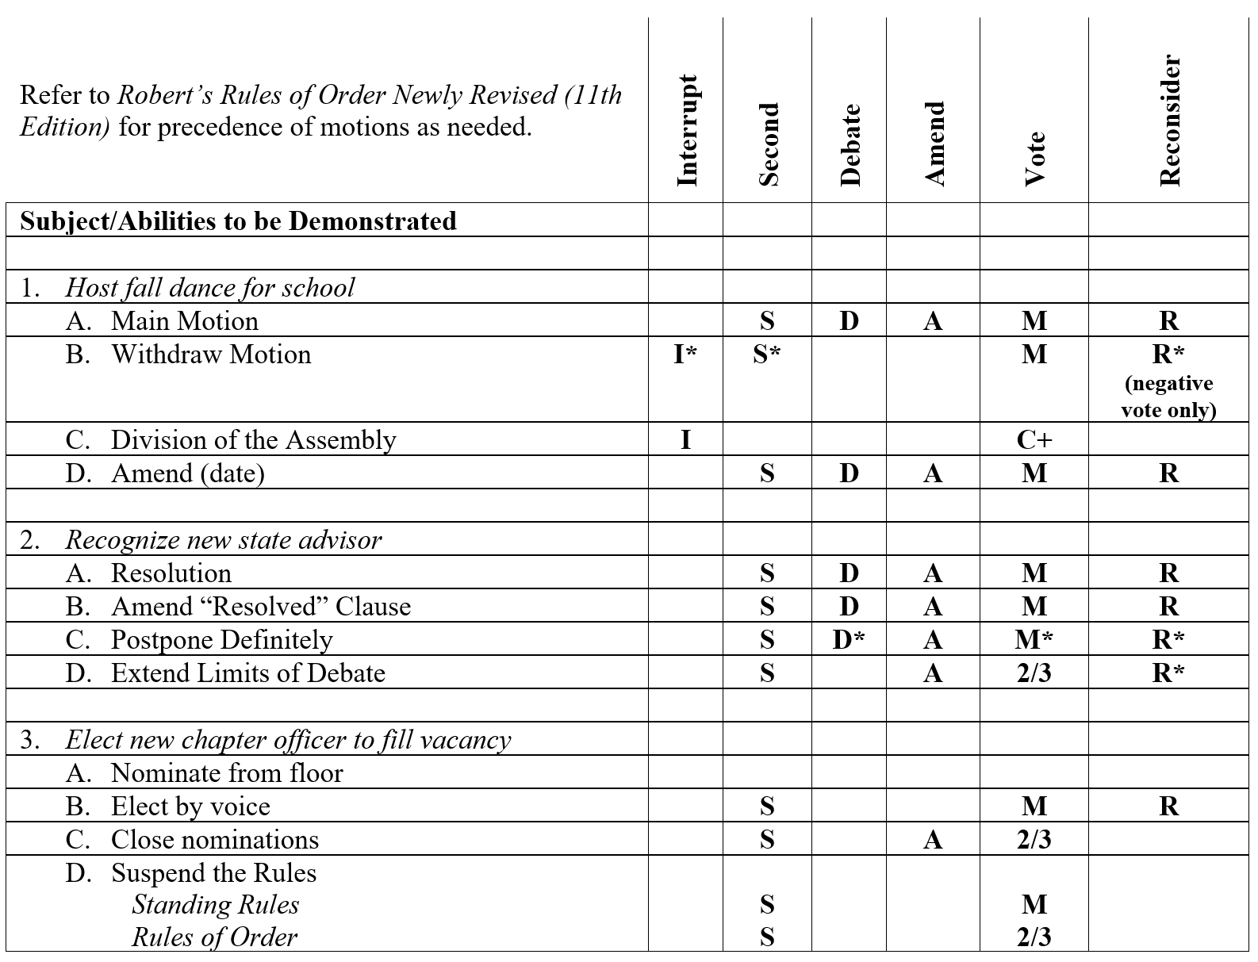

Meaning of Symbols
* – See Robert’s Rules of Order Newly Revised (11th Edition) for specific rule. Consult index and tinted pages for further information and page references.
# – A main motion when no other motion is pending.
I – Is in order when another has the floor.
S – Requires a second.
D – Is debatable.
A – Can be amended.
M – Requires a majority vote (i.e., more than half the votes cast).
2/3 – Requires a 2/3 vote (i.e., at least twice as many in the affirmative as in the negative); must be taken by a rising vote.
C – Usually no vote is taken. The chair responds.
C+ – Standing vote (chair or any member can demand it).
R – Can be reconsidered.

QUESTIONS BY THE JUDGES

Up to five (5) minutes will be allowed each team for questions by the judges. The following three questions will be directed to the chairman for any team member to answer. The team members may caucus. The secretary is not required to participate in the caucus or assist with answering questions if he/she voluntarily decides to continue writing his/her secretary's notes. Judges are not allowed to make up additional questions.

Questions will have reference to the abilities demonstrated during the event.

EACH JUDGE IS TO ASK THE SAME QUESTION(S) OF EACH TEAM. EACH TEAM MUST BE ASKED THE SAME NUMBER OF QUESTIONS.

- If a main motion is postponed definitely to the next chapter meeting, what does it become at that meeting?

ANSWER: Order of the Day

- At what point does it require the approval from the assembly for a motion to be withdrawn?

ANSWER: Once the motion has been stated by the chair.

- Is there a way that Suspend the Rules can be renewed during the current meeting?

ANSWER: Yes, by unanimous consent only.

Opening a Meeting

The opening ceremony sets the stage for a chapter meeting. The ceremony, done in a proper and professional manner, will demonstrate to the members a well-planned and organized meeting. This will make meetings more orderly and effective.

The Opening Ceremony
President
(Stands and raps the gavel once for attention.) The meeting will come to order. We are now holding a meeting of Business Professionals of America. Mr. /Madam Vice President, what are the major purposes of our professional organization?

Vice President
We recognize the importance and understand the contributions that have been made to our country by business professionals. We are preparing to take our place in these challenging positions. We work together in Business Professionals of America to develop essential competencies in leadership, scholarship, character, and citizenship so that we may share in the improvement of our economy and the advancement of our nation.

President
May we accomplish these objectives? Mr. /Madam Vice President, will you please present the other officers?

Vice President
With pleasure, I introduce:
(Introduce in order the President, Historian, Secretary, Treasurer, Parliamentarian, and Vice Presidents. Pronounce the name of each individual and the office held. As each officer is introduced, he or she should stand and remain standing until seated by the President.)
Mr. /Madam President, the officers are at their stations.

President
Will the members and friends please rise and join me in reciting the Pledge of Allegiance to the Flag? (Raps the gavel three times to call the members and guests to stand. The audience should rise on the third rap of the gavel. All members face the flag with their hands over their hearts to repeat the Pledge of Allegiance to the Flag.)

Everyone
I pledge allegiance to the flag of the United States of America and to the Republic for which it stands, one nation under God, indivisible, with liberty and justice for all.

President
Fellow members and guests, join me in stating why we are here.

Everyone
We are met in a spirit of friendship and goodwill as we prepare for careers in a world-class workforce. We work together to develop professionalism and leadership through Business Professionals of America and pledge our loyalty to our nation.

President
Please be seated.

Closing a Meeting

The closing ceremony, when properly presented, will bring a dignified closing to a session or meeting. It is an indication to the members or guests present that all business has been transacted.

Equipment and Supplies
Gavel

The Ceremony

President
Mr. /Madam Secretary, do you know of any further business which should be transacted at this time?

Secretary
(Rises, replies, and sits down.) I have none, Mr. /Madam President.

President
We are about to adjourn this meeting of the Business Professionals of America. As we associate together, let us be supportive of each other as we strive to attain the goals of this organization. (Pause) If there is no further business and no objection, the meeting will be adjourned. (Pause) I now declare this meeting adjourned. (Rap gavel once.)

